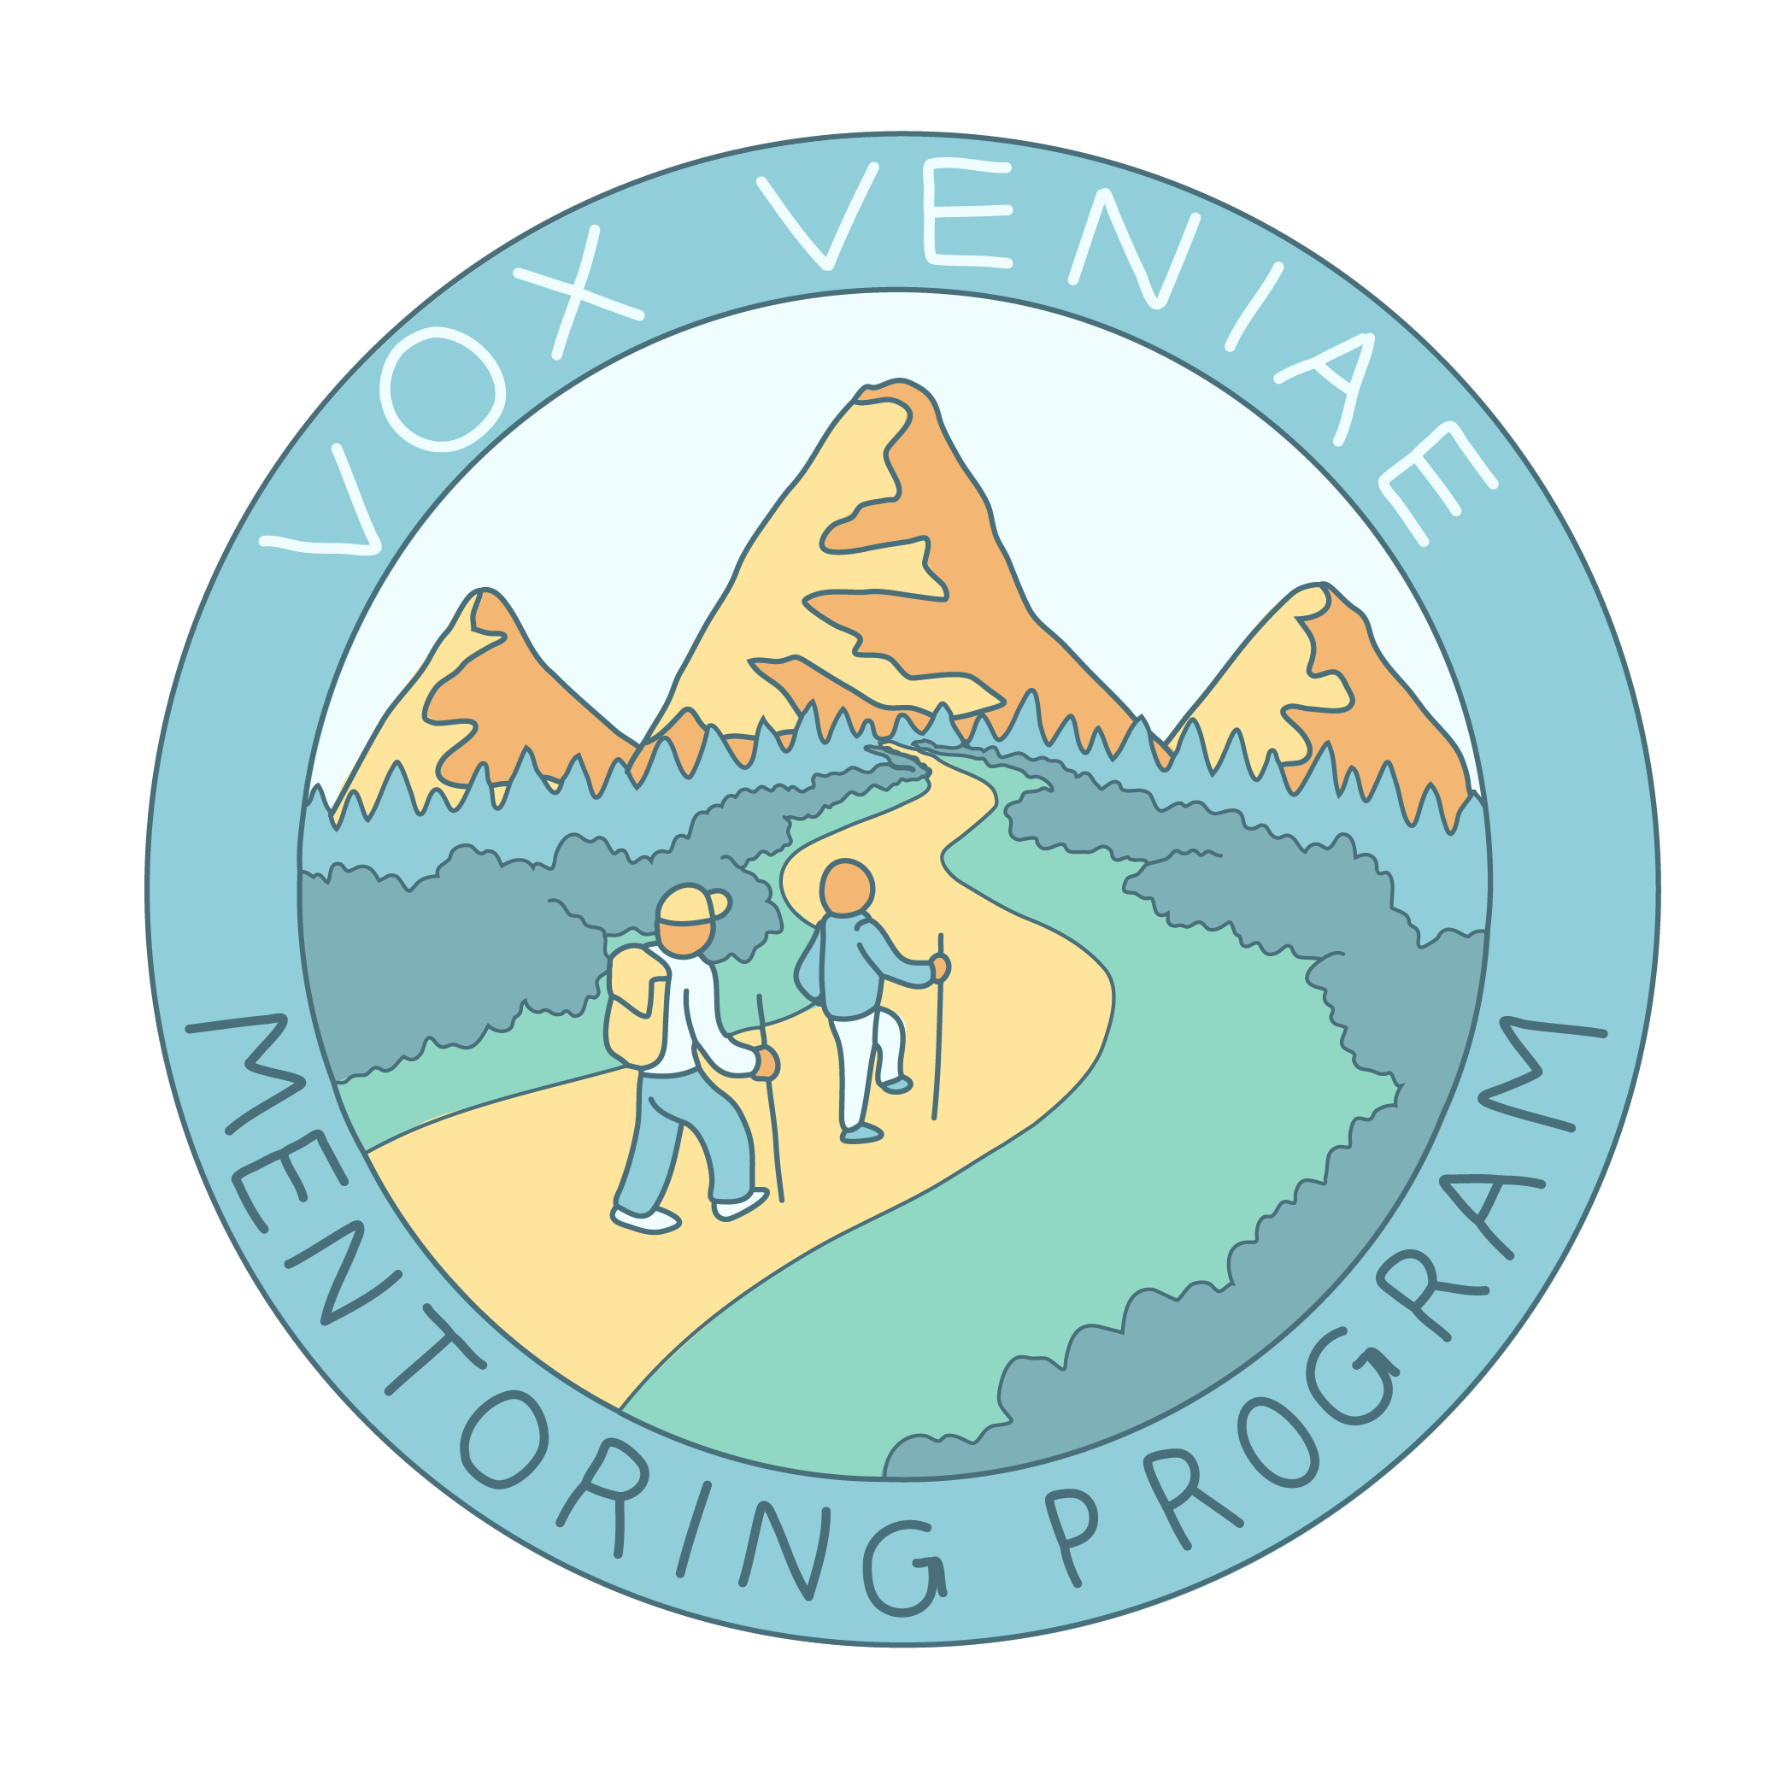
Vox Veniae Mentoring
PROGRAM INFORMATION

GOAL OF THE PROGRAM
- To promote spiritual growth by forming one-to-one covenantal relationships that provide mutual encouragement and accountability on a shared journey with Christ.
KEY DATES
- Orientation Meeting: April 19
- Applications Due: April 26
- Match Intro/Training: May 3
- Follow-up Meeting: TBD

PARTICIPANT EXPECTATIONS
- Attend Orientation, Training and Follow-up Meeting
- 6-month commitment
- Meet at least twice a month
- Focus on spiritual exploration

MATCH CRITERIA
- Person-level
  - Find a fit between what participants are looking for and what they want
  - People that are in complementing seasons of life
  - Similar interests or aspirations

- Surface-level
  - Proximity in Austin
  - Similar time availability

- Some matches will be age-based, some will be peer matches

STEPS OF ENTERING THE PROGRAM
- Orientation: General program info
- Application: Applications due two weeks after orientation
- Matching: Mentoring team and Vox leadership make matches
- Follow-up Training:
  - 6-months later
  - Matches will either close, extend, or rematch

MONITORING AND EVALUATION
- Open for email feedback any time at mentoring@voxveniae.com
- We will send out 3-month survey
- We will collect exit evaluations at 6-month training

